Habits

Ari Yeganeh
Oct 25, 2019 — 12 mins read
Picture a massive elephant with a rider on top trying to steer it where to go. The rider is our rational self; the elephant our emotional self.
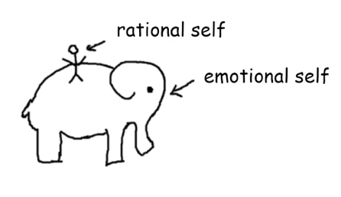
Me: Hey big guy, do you want to go to the gym tonight and get some exercise?
Elephant: *angry stumping*
Me: What about just a walk around the block?
Elephant: *more angry stumping*
Me: Fine, let’s just stay home have ice cream.
Elephant: Yay!
That is my internal dialogue whenever I want to get anything done in my life. A struggle between my rational adult self (my pre-frontal cortex) and my emotional childish self (my limbic system) who just wants to run around and have a good time eating ice cream. It’s not like I don’t know that exercise is good for me and too much ice cream is bad for me, everyone knows that. But why is it so hard to do what we know is rationally right?
Imagine explaining this to an alien? We are the most intelligent species on our planet capable of sending rockets to space, but for the most part we don’t have control over our own bodies. Sure, we can move our limbs around when we focus on them and we have some voluntary control so we don’t pee ourselves. But do you really think we would survive if the most vital functions were left to our own control?
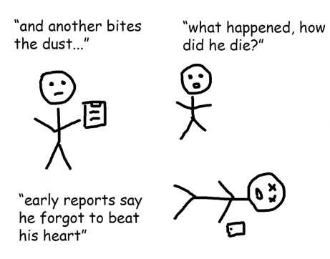
Luckily, evolution has automated the surviving part of being a human. Our bodies run like clockwork. We breathe in and the lung extracts oxygen to be sent into our blood. The heart pumps the blood around our body. Each cell knows its function and operates almost entirely without our control. Thank god.
Unluckily for us, evolution has not yet automated the parts of being a human that are not related to survival. What a bummer.

Enter willpower
Back to our elephant. After multiple failed attempts in reasoning with emotional elephant, I can’t take it anymore. Drowning in my own self-pity, I take out my stick.
Smack. Don’t eat that cake.
Smack. Turn off Facebook.
Smack. Go to the gym.
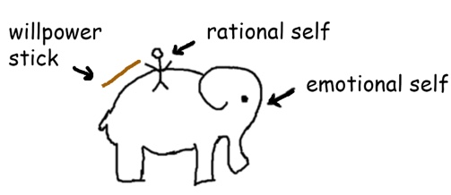
And it works, my emotional elephant doesn’t like getting smacked. It listens. For now.
But what happens to an elephant who continually gets smacked against its will?
It throws the rider off and decides to go for a wander. A wander down temptation alley.
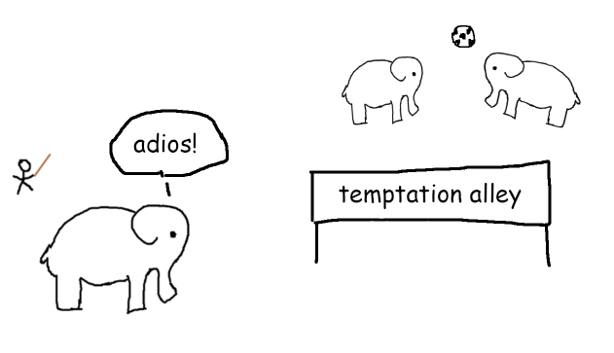
Oh look, a whole cake, binge!
Oh look a new notification, scrolls phone for an hour!
Oh look a comfy couch, snooze!
The truth is that our emotional elephant is too powerful. Eventually it will do what it wants to do. What feels good. Especially when we are stressed, tired and hungry. Willpower goes out the window and our elephant roams freely doing what it pleases.
My own experiences and lots of empirical studies* have shown that willpower is a limited resource. Whilst it can be developed and can grow stronger over time, in any given day we have a limited reserve.
This is why Brian Tracy wakes up every morning and eats a live frog. No, Brian is not as weird as you would think. He is one the most successful business authors in the world. Rather Brian has uncovered that his willpower is highest first thing in the morning. He doesn’t literally eat the poor frog but rather sees the frog as a metaphor for the most difficult and important task he has to do that day.
So willpower whilst generally very useful cannot always be relied on. The more we use our willpower stick in a day, the less our elephant wants to listen to us.
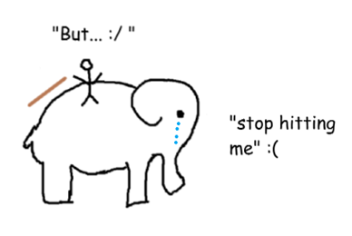
Instead what if there was another way to train our elephant without relying on the stick?

Taming the elephant
Have you ever paid attention to how you walk?
Unless you’re a runway model, chances are – probably not. You stand up and your body somehow knows how make the right movements, accounts for gravity, objects around you and your balance and left and right you go. Your body is on autopilot.
Now imagine deliberately thinking about every step. Lifting your leg up, consciously looking at the floor beneath you, trying to keep a straight back – pausing – and repeating the same movement for your other leg.
This is the difference between willpower and habits. Whereas willpower requires deliberate thought from our rider, habits are carried out on auto-pilot by our elephant.
If willpower is a stick, then habits are clearly marked paths for our elephant. It’s easy to walk down them because our elephant knows the way.
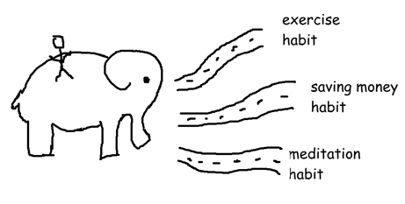
And here is the good news, the more you walk down a path, the easier it gets. At first it might have seemed like a chore to brush your teeth every night or wash your hands after using the bathroom. But over time this became second nature.
Research* shows that we can form habits as quickly as 2-3 weeks; the more difficult the habit, the more time it takes to form. But once a habit is formed, our elephant takes the lead and our rider can take some much needed z’s.
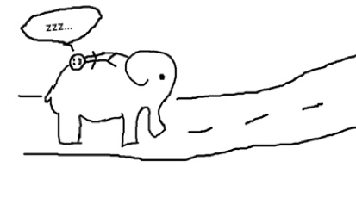

How to form habits
For about a year I struggled to make my exercise habits stick. I found it a chore to wake up early and was tired after work so I never got around to it. I always had an excuse for not working out: “I’m tired today”, “I have too many things on”, “It’s Friday, give me a break”
That was until I came across a book called The Power of Habits by Charles Duhigg. The book made it perfectly clear to me why I couldn’t stick to my exercise habit. This is how it broke down the components of any habit:
- Reminder (cue) – the trigger that initiates the behavior
- Routine – the behavior itself; the action you take
- Reward – the benefit you gain from doing the behavior
All I had so far was the exercise routine, not the reminder or reward.
I started with setting a reminder. I found phone reminders naggy and annoying. That didn’t work. Instead I looked at my day and wrote down actions I took without fail that I could use as reminders: waking up, brushing teeth, eating, getting dressed and so on…
The reminder that was the most powerful for me was hunger. I found if I got really hungry I would be motivated to work out (or do anything) just so I can eat. I liked food too much. More than the pain of an intense workout.
And thanks to this new discovery my new habit started to stick. I started consistently exercising every other day. I had all the components of a habit: reminder (hunger), routine (workout) and reward (food).
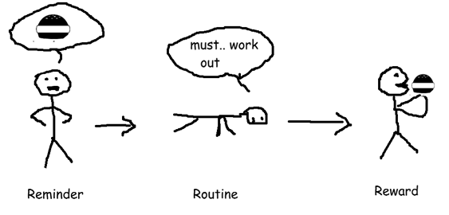
All was well and good….except it wasn’t.
It turns out I couldn’t completely rely on hunger to motivate me. Every molecule of my body craved food. I got hangry: a dangerous combination of hunger and anger. I lost all my inhibitions. My willpower and habit both went out the window. My elephant was in full control and he just wanted to eat.
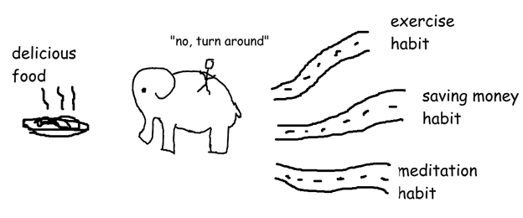
This disappointed me at first. How could I not control my hunger and give in so easily? Am I going to break all my habits like this? Was there something wrong with me?
And then I discovered yes there was something wrong with me; I was human. A bag of meat and bones, full of imperfections, complex emotions and conflicting desires. Part of an intelligent species of other humans who share this common trait with me: fallibility.
The first couple of times I caved in to my hunger, I beat myself over it and felt disappointed with my newly formed habit. However these feelings didn’t help me at all. Instead what helped me get up and try again the next day was self-compassion. Acknowledging that I’m going to mess up and not honour my word sometimes and that I’m not the only human struggling with this problem. Every day millions of people start new diets and exercise programs and everyday millions of people fail.
As I continued to fight my self-criticism with with self-compassion I learnt a far more important lesson…

Power of baby steps
Imagine if a wizard gives you a magic wand that can improve any aspect of your life by 0.1%.
Abracadabra. 0.1% more money in your bank account
Abracadabra. 0.1% improvement to your health
Abracadabra. 0.1% more knowledge about the world
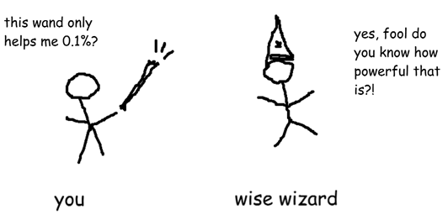
At first, it doesn’t look like a very useful magic wand, you might want to give it back to the lazy wizard who gave it to you. Most people might not even bother to use it. But what if you could use the wand once a day for as long as you liked? Would you use it then?
Maybe you might pick it up, play around with it for a couple of days or weeks to see if you notice an impact. Strange, you think to yourself. I’ve used this damn wand for a whole month. Why am I not buffed yet? Where is my six pack?
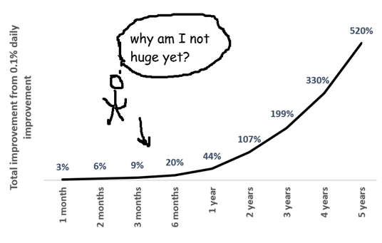
And this is exactly why 80% of gym memberships are canceled within the first few months. People sign up excited about losing weight normally at the start of the year but after a few weeks they give up because they don’t see any results. Just like the magic wand, they don’t see the invisible 0.1% improvements to their health from each visit to the gym.
But in reality it is exactly these 0.1% baby steps over time that make all the difference. If you kept going just a bit longer, a year of 0.1% improvements everyday will result in a 44% total betterment of any field of your choosing. Two years, 107% improvement. And in 5 years, a massive 520% improvement.
This is the compound power of habits. Tiny actions over time can lead to massive results. This lesson alone made all the difference for me.

Which habits to form
You probably don’t need some young internet guy who draws really bad stick figures to tell you which habits you should or shouldn’t have. You are the best person to assess which habits you need to live a more fulfilled life.
But if you need some inspiration, here are three habits that have significantly improved my life:

1. Exercise
There are no surprises that exercise is good for us. I have spent half this article banging on about it. From helping you live longer, reducing the chance of heart disease, diabetes, strokes, cancers and on top of this making you look sexy*. This would have to win the award for me as the best overall habit to form on a daily basis.
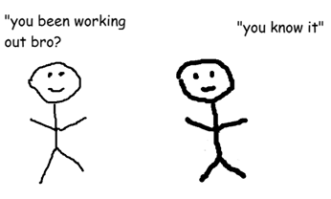
A funny thing happened when I started to exercise regularly. My body started to crave much leaner and more nutritious foods and I could no longer stomach junk food. My sleep quality also improved and I had a lot more energy throughout the day. I felt alive. However, on the days I wouldn’t exercise, I ate more junk food, got less quality sleep and had less energy throughout the day and needed more coffees instead.
How to start: A simple 10 minute walk everyday for a week is far superior than a 70 minute walk once a week. Because the daily action starts forming a habit, whereas a one off walk doesn’t. Whilst everyone will have a different exercise routine, the key is consistency, consistency and consistency. Bonus points if you can join a social exercise routine like a sports team and/or a grueling boot-camp where you pay a ex-soldier to yell at you to workout. Again experiment and see what works for you.

2. Mindfulness practice
It’s difficult to go a day without a spiritual guru or personal development coach telling you why you should meditate and be more mindful. And yes there are over 1000 studies* on the benefits of having a consistent mindfulness practice. From reducing symptoms of stress, chronic pain, depression, anxiety to improving immune function, mood regulation, concentration, memory and most impressive of all creating new grey matter in the brain. It’s a surprise no one has been able to sell us a mindfulness pill yet.
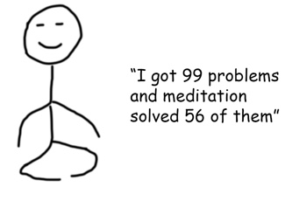
I’ve noticed in reality though, most people can’t stick to strict mindfulness practices. They start with a rosy idea of meditating 20 minutes a day and realise soon after how pathetic and neurotic they are and give up all together. There is a misconception that if you’re not floating off the ground within a few minutes then you’re probably not meditating right.
In my own spiritual quest, I have discovered mindfulness does not have to involve sitting down and meditating but can also be found in everyday experiences. Whether it’s sitting on the bus and listening to music and really hearing every chord and melody, whether it’s walking to work and just noticing the glitter of leaves over your head and the songs the birds are singing; or whether it’s sipping on a hot coffee on cool autumn’s day and giving your whole body to the aromatic experience unfolding before you. Mindfulness comes in many different forms.
How to start: the essence of mindfulness is focused attention. This can come in many forms. The easiest way to start is by taking just 1 breath. Observing the air entering the nostrils, slowly entering the lungs, the belly rising, the shoulders and chest lifting. And then following the air out of the nostrils and observing the relaxation of the body.
That’s how I started. Every night before bed, I made a commitment to myself to take 1 mindful breath before sleeping. It’s hard not to have time for a single breath. And over time I added to this 1 breathe eventually being able to sit and focus for 20 minutes and more.
But equally, you could replace this mindful breath with any activity that helps you focus your attention. Most practitioners recommend the breath as it’s the most accessible tool. The key like any other habit is consistency of practice.

3. Reading
It’s insane to think that a person has poured years of their experience and imagination into a book and through the magical invention of words this person can beam their creation straight into our heads. Yet most people don’t read.
Imagine being inside Bill Gates’ head for a couple of hours? Do you think you might learn something new? Or what about a day in the life of Pele, one of the greatest football players that ever lived. This is the power of reading. It is the closest thing we have to telepathy; yet the average person reads just 4 books a year, the average CEO 50 a year. And it’s not just non-fiction, fictional stories offer us a wonderland of opportunity to enter vivid worlds not possible in this life, opening our minds to completely new possibilities.
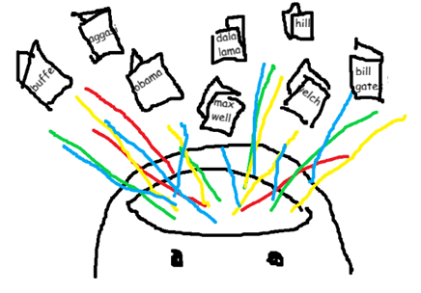
How to start: some people love the feeling of good old books in their hands and the aroma of musky paper. Others find carrying a kindle the most effective, others yet aren’t into visual learning and prefer audiobooks. Whatever your preferred method, start with baby steps. Pick a topic that interests you and make a date with yourself to read about it everyday even if it’s just 1 page. I started with hardback books because I loved the feeling of holding a book and being able to easily lend it to my friends. Over time I moved to audiobooks as I was able to finish books 2-3x faster by increasing the narration speed. Again experiment and see what works for you.

What is your elephant like?
We all start with a wild emotional elephant, some more wild than others. On some days we go on a beautiful safari and our elephant is our best friend. On other days, we are up against the lions and our elephant has run off to temptation alley.
I still argue with my elephant on a daily basis but with each day our relationship grows stronger as we take one baby step at a time towards our ideal selves…
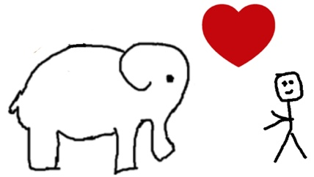
Share in the comments below what is the relationship with your emotional elephant like?
Resources I used to write this post:
- The Power of Habit – Charles Duhigg
- The Slight Edge – Jeff Olson
- The Willpower Instinct – Dr. Kelly McGonigal
- Eat that Frog! – Brian Tracy
- Transform your Habits – James Clear
References:
- *Studies on willpower depletion (Muraven and Baumeister, 2000; Baumeister et al., 2008; or see Hagger et al., 2010, or Bucciol, Houser, and Piovesan, 2010)
- *Studies on exercise https://kspope.com/ethics/exercise-meta-analyses.php
- *Studies on meditation https://www.ncbi.nlm.nih.gov/pubmed/22582738

